**VARUN KUMAR**

**2K19 / IT /140**

**OOP LAB-2**

Q1. Create two structures called bank_employee (name, empid, salary, age, city_of_work) and bank_branch ( branchid, branch_city,bonus_offered_to_employees) Take the input for all the fields from user. Create a database of 5 employees and 5 branches.

CODE –

#include <stdio.h>

struct bank_employee {

char name[25];

int empId;

int salary;

char city_of_work[20];

int total_salary_with_bonus;

};

struct bank_branch {

int branchId;

char branch_city[20];

int bonus_offered;

};

int main() {

struct bank_employee E[5];

struct bank_branch B[5];

for(int i=0 ;i<5 ;i++){

printf("enter name: ");

scanf("%s",&E[i].name);

printf("enter employee ID: ");

scanf("%d",&E[i].empId);

printf("enter salary: ");

scanf("%d",&E[i].salary);

printf("enter city of work: ");

scanf("%s",&E[i].city_of_work);

printf("enter branch ID: ");

scanf("%d",&B[i].branchId);

printf("enter branch city: ");

scanf("%s",&B[i].branch_city);

printf("enter bonus_offered: ");

scanf("%d",&B[i].bonus_offered);

E[i].total_salary_with_bonus = E[i].salary + B[i].bonus_offered;

}

printf("\n");

for(int i=0 ;i<5 ; i++){

printf("Name: %s\n", E[i].name);

printf("employee ID: %d\n", E[i].empId);

printf("salary: %d\n", E[i].salary);

printf("city of work : %s\n",E[i].city_of_work);

printf("total salary with bonuses : %d\n\n",E[i].total_salary_with_bonus);

}

return 0;

}

**INTPUT -** enter name: Singh

enter employee ID: 1

enter salary: 50000

enter city of work: Delhi

enter branch ID: 10

enter branch city: Delhi

enter bonus_offered: 20000

enter name: Rawat

enter employee ID: 2

enter salary: 60000

enter city of work: Lucknow

enter branch ID: 20

enter branch city: Lucknow

enter bonus_offered: 10000

enter name: Kaushik

enter employee ID: 3

enter salary: 50000

enter city of work: Chandigarh

enter branch ID: 30

enter branch city: Chandigarh

enter bonus_offered: 15000

enter name: Verma

enter employee ID: 4

enter salary: 55000

enter city of work: Agra

enter branch ID: 40

enter branch city: Agra

enter bonus_offered: 11000

enter name: Sharma

enter employee ID: 5

enter salary: 40000

enter city of work: Amritsar

enter branch ID: 50

enter branch city: Amritsar

enter bonus_offered: 13000

OUTPUT -

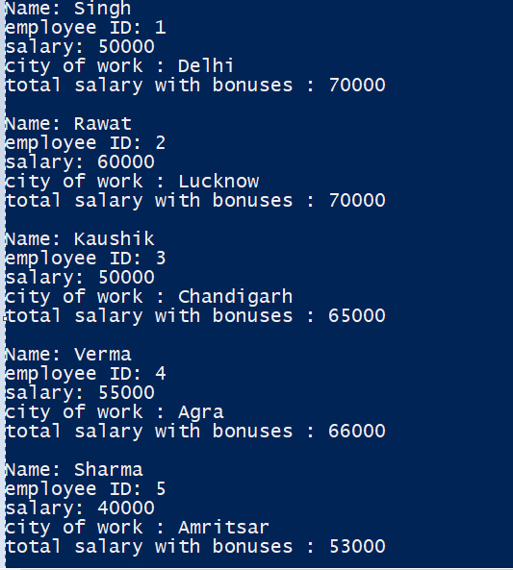

Q2. Include the concept of nested structure address in it, such that each employee has an address and branch also has an address. Print the branch’s full address on the basis of employees value in city_of_work

CODE -

#include <stdio.h>

struct bank_employee {

char name[25];

int empId;

int salary;

char city_of_work[20];

int total_salary_with_bonus;

};

struct bank_branch {

int branchId;

char branch_city[20];

int bonus_offered;

struct Branch_address{

char Building_no[5];

char Area[20];

}a;

};

int main() {

struct bank_employee E[3];

struct bank_branch B[3];

for(int i=0 ;i<3 ;i++){

printf("enter name: ");

scanf("%s",&E[i].name);

printf("enter employee ID: ");

scanf("%d",&E[i].empId);

printf("enter salary: ");

scanf("%d",&E[i].salary);

printf("enter city of work: ");

scanf("%s",&E[i].city_of_work);

printf("enter branch ID: ");

scanf("%d",&B[i].branchId);

printf("enter branch city: ");

scanf("%s",&B[i].branch_city);

printf("enter bonus_offered: ");

scanf("%d",&B[i].bonus_offered);

getchar();

printf("enter branch address:-\n Enter Building_no : " );

gets(B[i].a.Building_no);

printf("enter Area: " );

gets(B[i].a.Area);

E[i].total_salary_with_bonus = E[i].salary + B[i].bonus_offered;

}

int employee_id;

printf("\n");

printf("enter employee id to be searched: ");

scanf("%d",&employee_id);

printf("\n");

for(int i=0 ;i<3 ; i++){

if(E[i].empId==employee_id){

printf("employee name: %s\n",E[i].name);

printf("Branch_address :-\n" );

printf("Building_no : %s\n",B[i].a.Building_no);

printf("Area: %s\n",B[i].a.Area );

printf("City : %s\n", B[i].branch_city);

break;

}

}

return 0;

}

INPUT –

PS C:\Users\NISHANT\Documents> .\oop.exe

enter name: Singh

enter employee ID: 1

enter salary: 50000

enter city of work: Delhi

enter branch ID: 1

enter branch city: Delhi

enter bonus_offered: 20000

enter branch address:-

Enter Building_no : B-67

enter Area: Ganesh Nagar Complex

enter name: Rawat

enter employee ID: 2

enter salary: 60000

enter city of work: Chandigarh

enter branch ID: 20

enter branch city: Chandigarh

enter bonus_offered: 10000

enter branch address:-

Enter Building_no : A-87

enter Area: Mayur Vihar ph-2

enter name: Kaushik

enter employee ID: 3

enter salary: 50000

enter city of work: Lucknow

enter branch ID: 30

enter branch city: Lucknow

enter bonus_offered: 15000

enter branch address:-

Enter Building_no : F-105

enter Area: Pandav Nagar

enter employee id to be searched: 2

OUTPUT –

